2400～2500/5150～5850MHz 5dBi Vertical
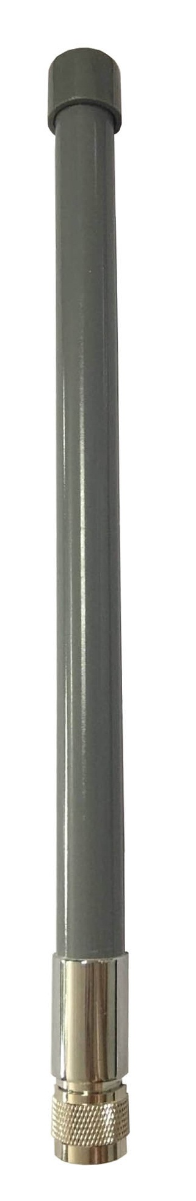
Parameter | 245805CA
Ｆｒｅｑ(MHz) | 2400-2500 | 5150-5850
bandwidth(MHz) | 100 | 700
Polarization | Vertical
gain(dBi) | 5
input resistance (Ω) | 50
ＶＳＷＲ | ≤2
max power(W) | 50
connector type | N ＭＡＬＥ
antenna length(cm) | 30
antenna weight(kg) | 0.2
Cover material | fiberglass
Diameter（ｍｍ） | ２３ｍｍ

